October 2020: Y11 Home Learning

Dear Parents and Carers

I hope that you and your family are keeping safe and well. As your child is currently working from home, you will be aware that their lessons have moved onto Google Classroom. When logging into their classrooms, students are expected to access their lessons as per their usual timetable. For example, if they have English Monday Period 1, they should complete their English lesson between 9:10-10:25am. This will support them with time management, and ensure they are able to access all of the lessons as they would in school.

There is also further guidance below regarding successful home learning. As well as this, on our school website, our ‘home learning’ page, has a range of videos and support materials for accessing and uploading work via Google Classroom.

As we are approaching the end of the half term, alongside students’ classwork, some subjects have also set assessments for students to complete and submit. The majority of these assessments have been set on Google Classroom with clear instructions for completion.

However, also included with this letter are any assessments which must be completed on paper due to the structure of the questions and content. Please could students complete these assessments, as per the instructions set by the relevant teacher within Google Classroom, and return them to school on Friday 23rd October. This is the return date for students within this isolation period.

Please could we ask that all students are adhering to the assessment expectations as set out by their teachers:
- Complete the assessment within the time frame set by your teachers.
- Complete the assessment without any revision notes - as you would within class.
- Only using the equipment specified within the assessment instructions.

Thank you for you continued support during this time. We continue to put your child’s education and wellbeing at the centre of everything we do and your support in allowing us to do this in invaluable.

Kind regards

Mr Rhodes
Headteacher

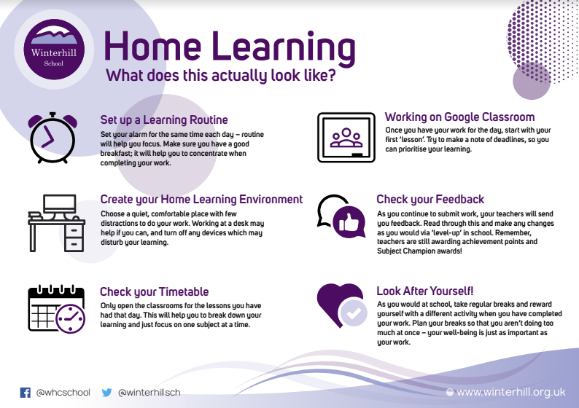

Lesson | Timing
Period 1 | 9:10-10:25am
Period 2 | 10:25: 11:40am
Break | 11:40-11:55am
Period 3 | 11:55am-1:10pm
Lunch | 1:10-1:45pm
Period 4 | 1:45-3:00pm

